Name Date
Stage 9 End of unit 5 test
1 Show why the sum of the interior angles of any hexagon must be 720 °.

[2]
2 a Work out the sum of the interior angles of a regular octagon.
[2]
b Work out the interior angle of a regular octagon.
[1]
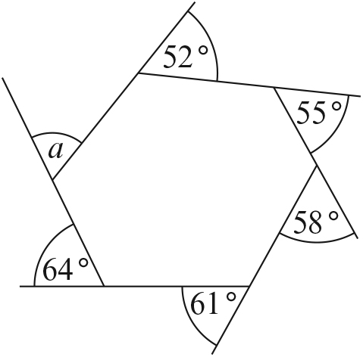
3

Calculate the size of angle a.
[2]
4 ABCD is a trapezium. CDE is a straight line.
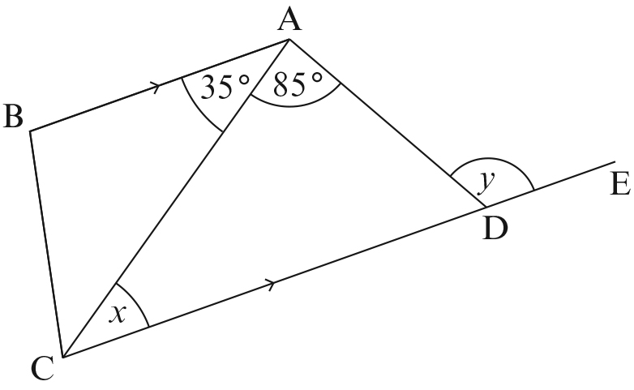

Work out the size of
a angle x
b angle y [2]
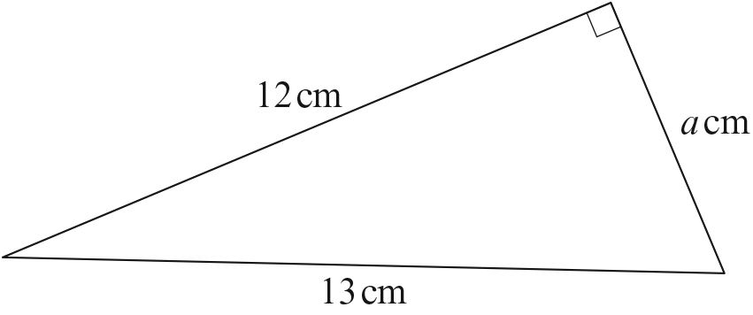
5

The sides of this right-angled triangle are 12 cm, 13 cm and a cm.
Show that a is an integer.

[2]
6 The floor of a room is a rectangle.
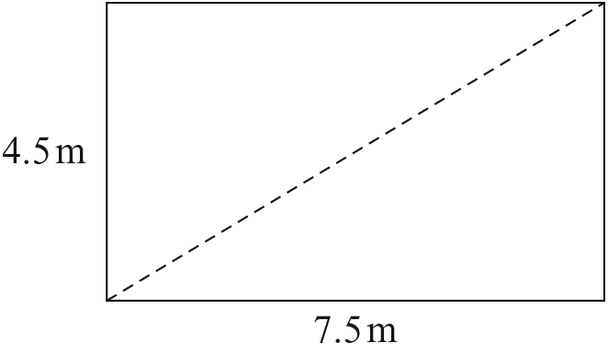
The sides of the rectangle are 4.5 m and 7.5 m.
Calculate the length of the diagonal of the rectangle.

[2]

7 Leave your construction lines in your answer to this question. You must not use
a protractor.
The sides of a triangle are 6 cm, 7.5 cm and 8.5 cm.
a Make an accurate drawing of the triangle. [2]
b Draw the perpendicular bisector of the longest side. [2]

8 Leave your construction lines in your answer to this question. You must not use a protractor.
Construct an angle of 22.5 °. [3]

[Total: 20 marks]

END OF TEST

